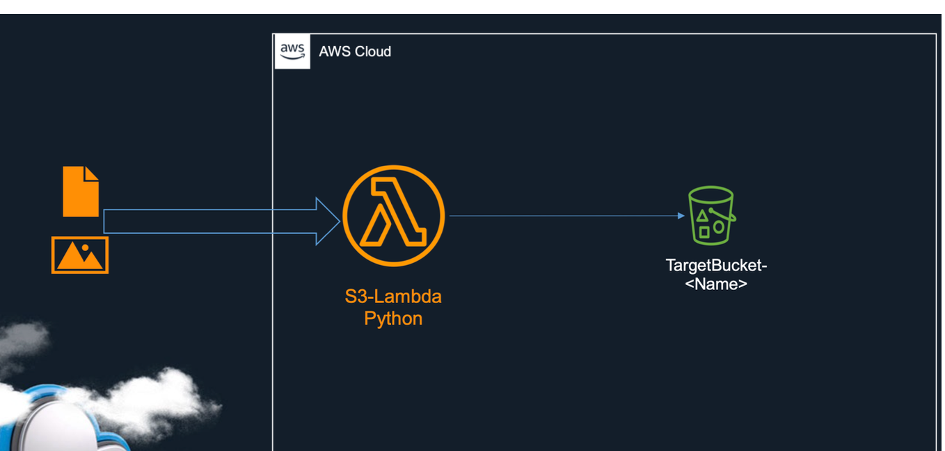
Question1:
Create a lambda function to copy a text file to an s3 called targetBucket yourname (search for the code)

- screenshot From the lambda
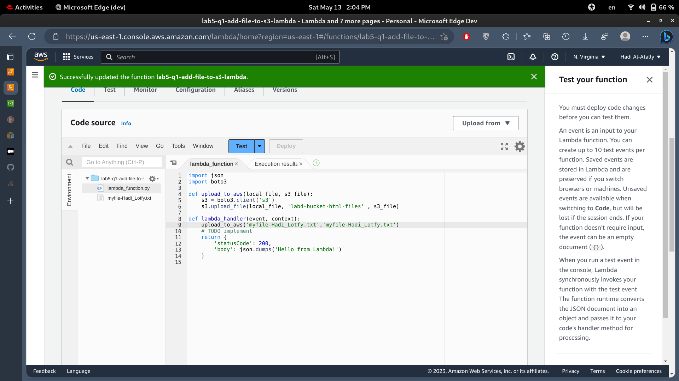

- Screenshot from the s3 with the file uploaded from lamba
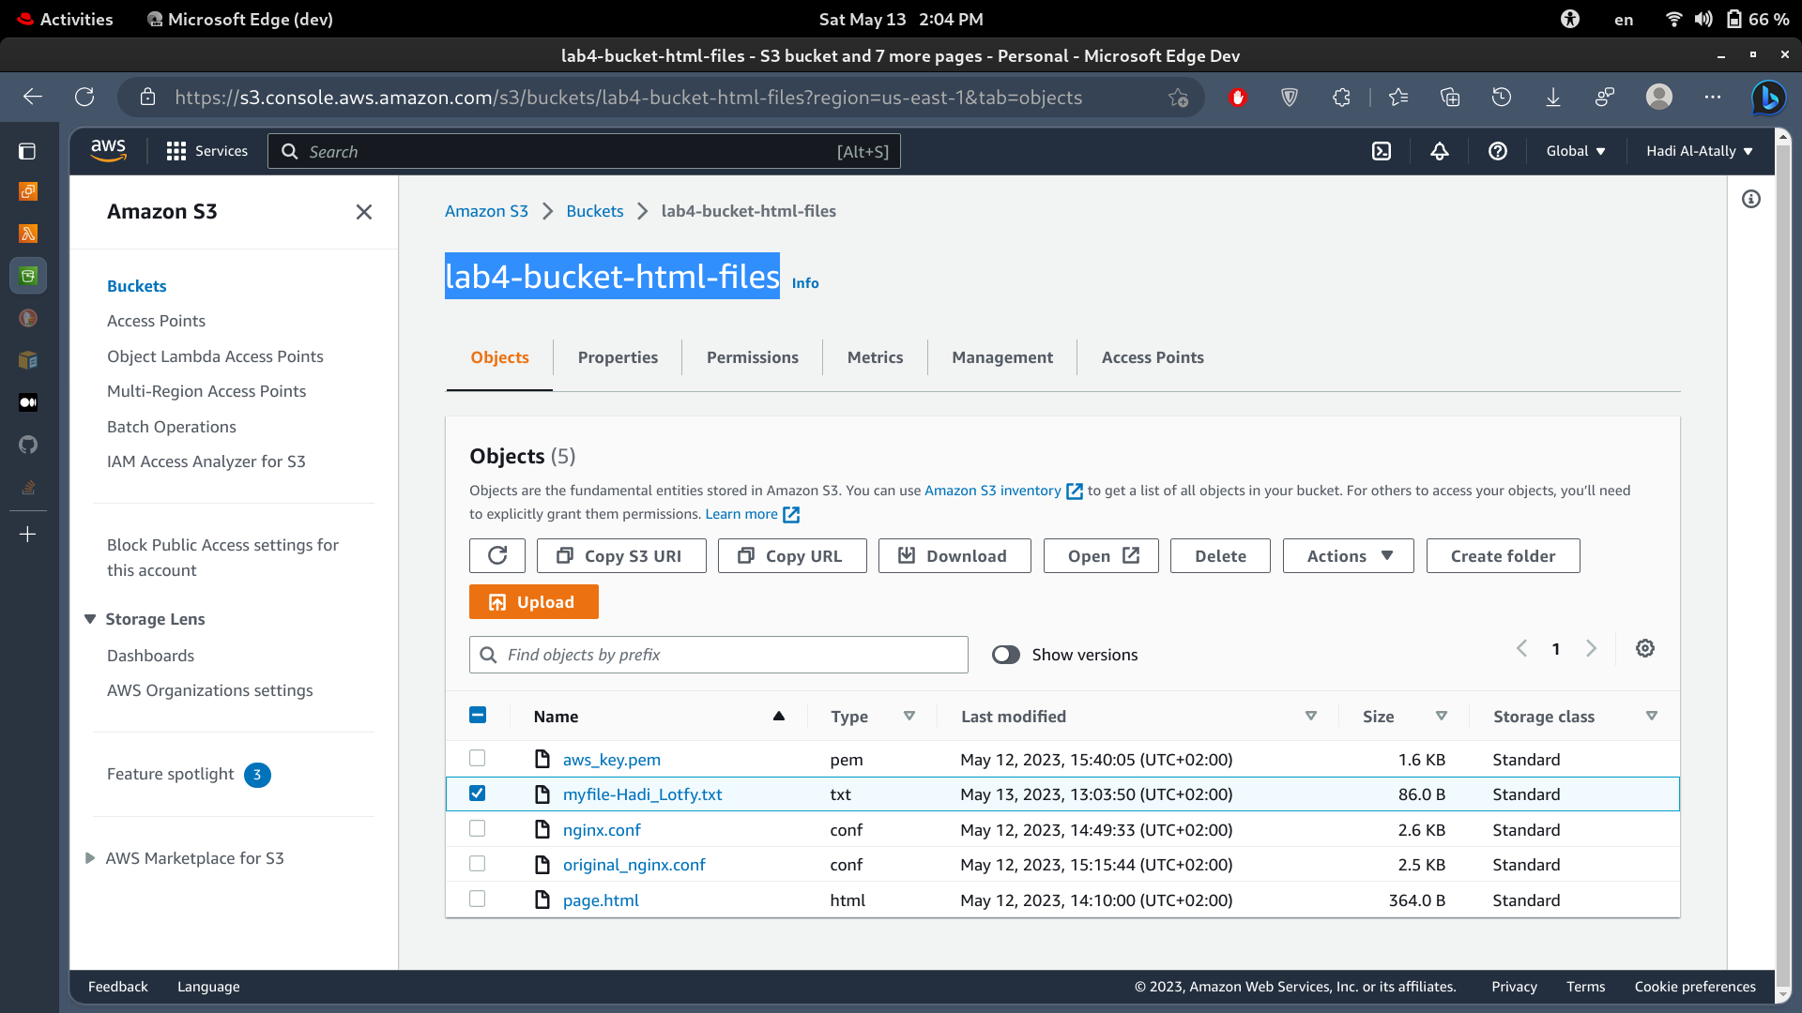

Question2:
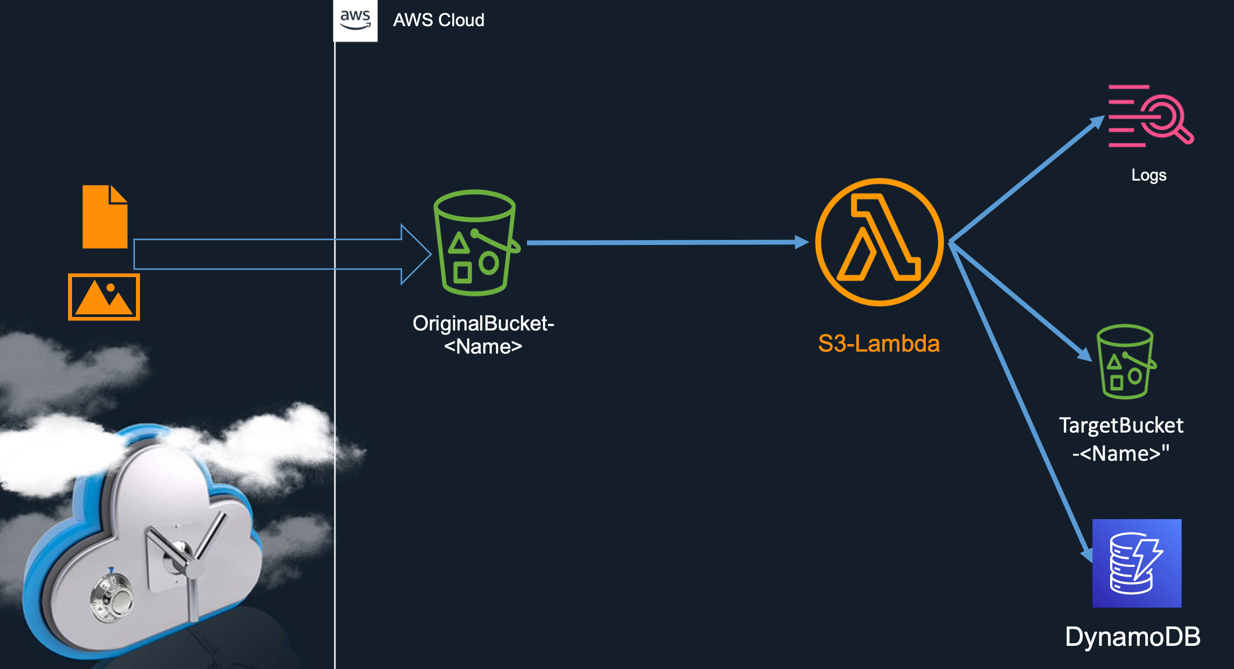
Create a lambda function to be triggered when you upload a file to s3 called sourcebucket-yourname , the lambda will copy the uploaded file to an s3 with name target-bucket-yourname And save the name of the file to dynamodb
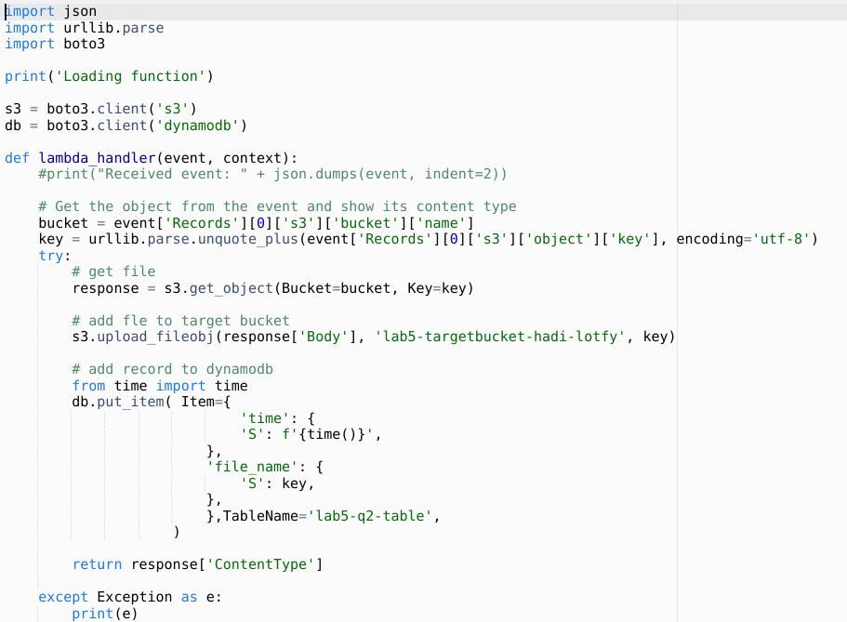
- screenshot From the lambda
- Screenshot from the target-s3 with the file uploaded from lambda. (Here are the source and the destination!)
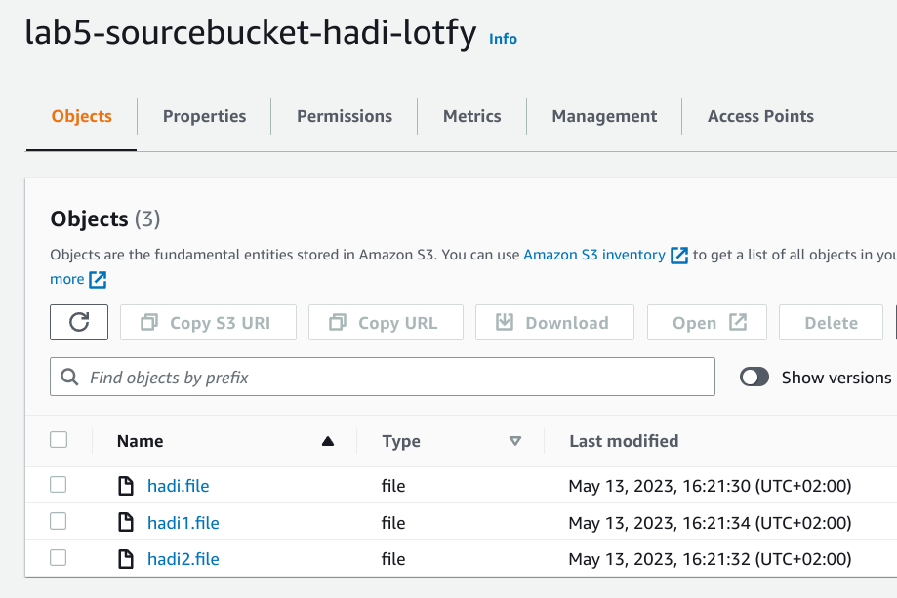
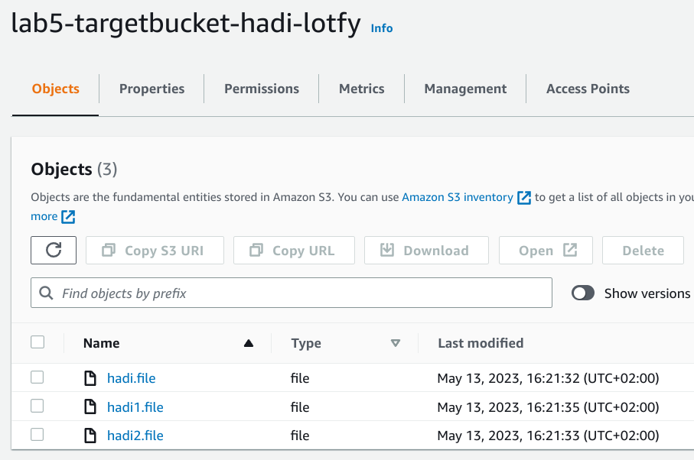
- Screenshot from dynamomdb with the file name saved into it

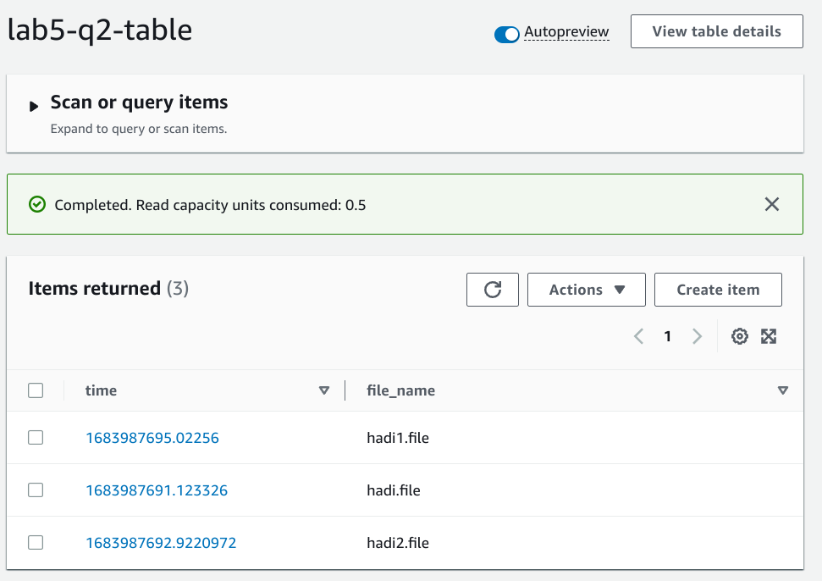

Question3:
Create an EKS On aws to be a private one with any application deployed into it and access this app from the browser.

Firstly : my architecture
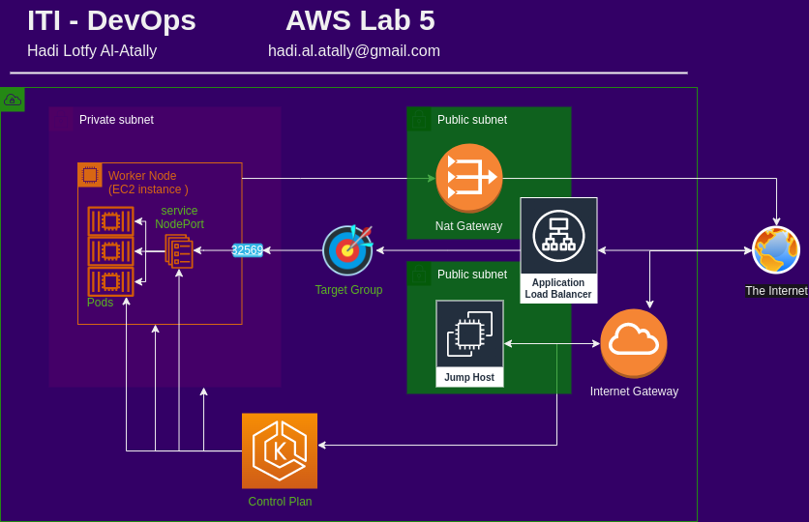
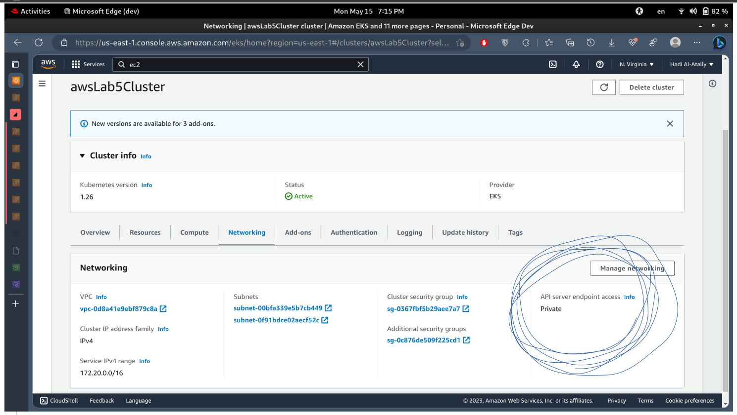
- Screenshot fom eks settings

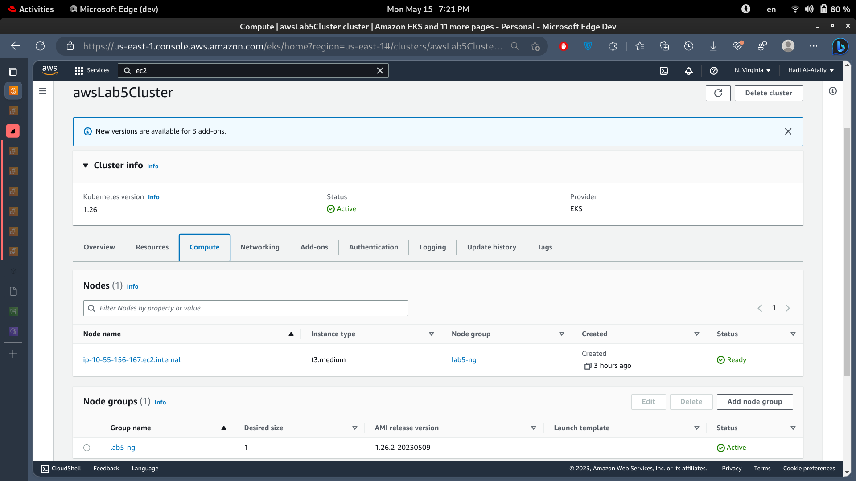
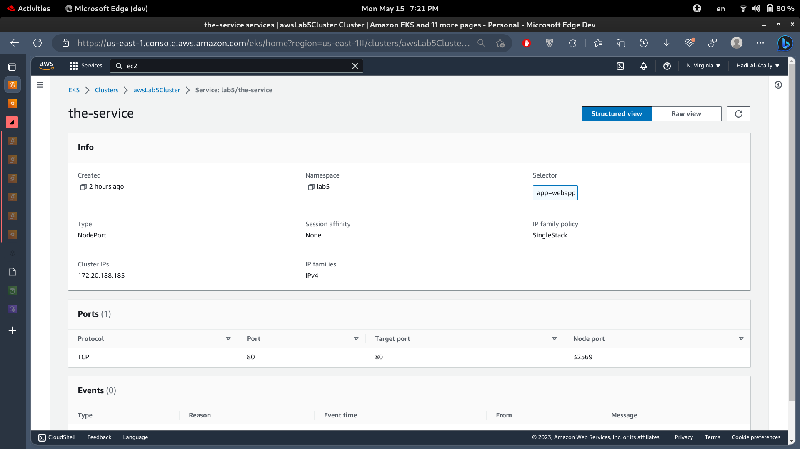

Screenshot from the app using kubctl get
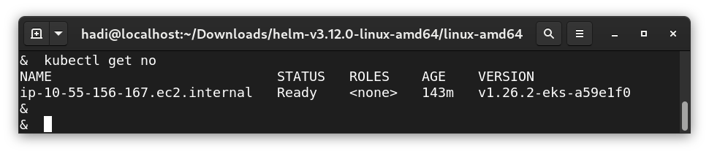
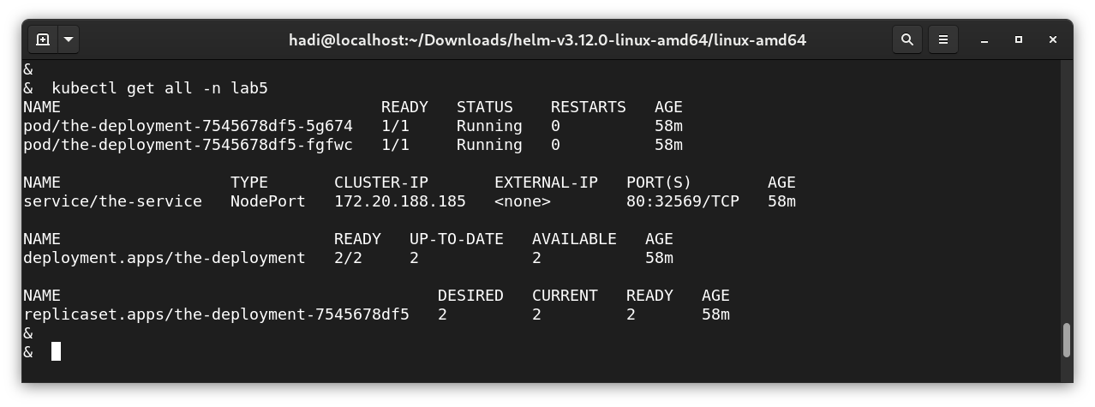
Screenahot from accessing the app
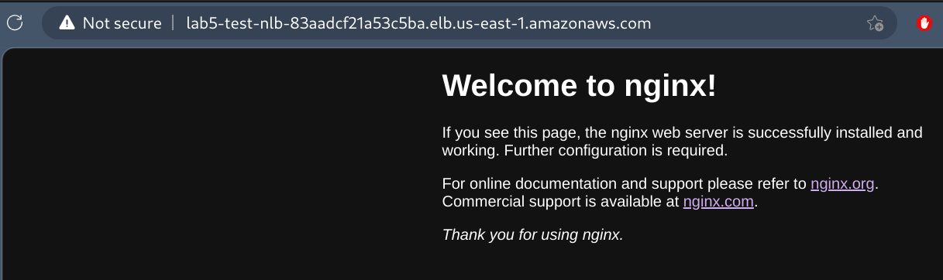

Additional screenshots:
- how to access cluster control plan: use jumb host in the same vpc as the cluster, install aws and kubectl on it and configure aws credentials and kubectl .
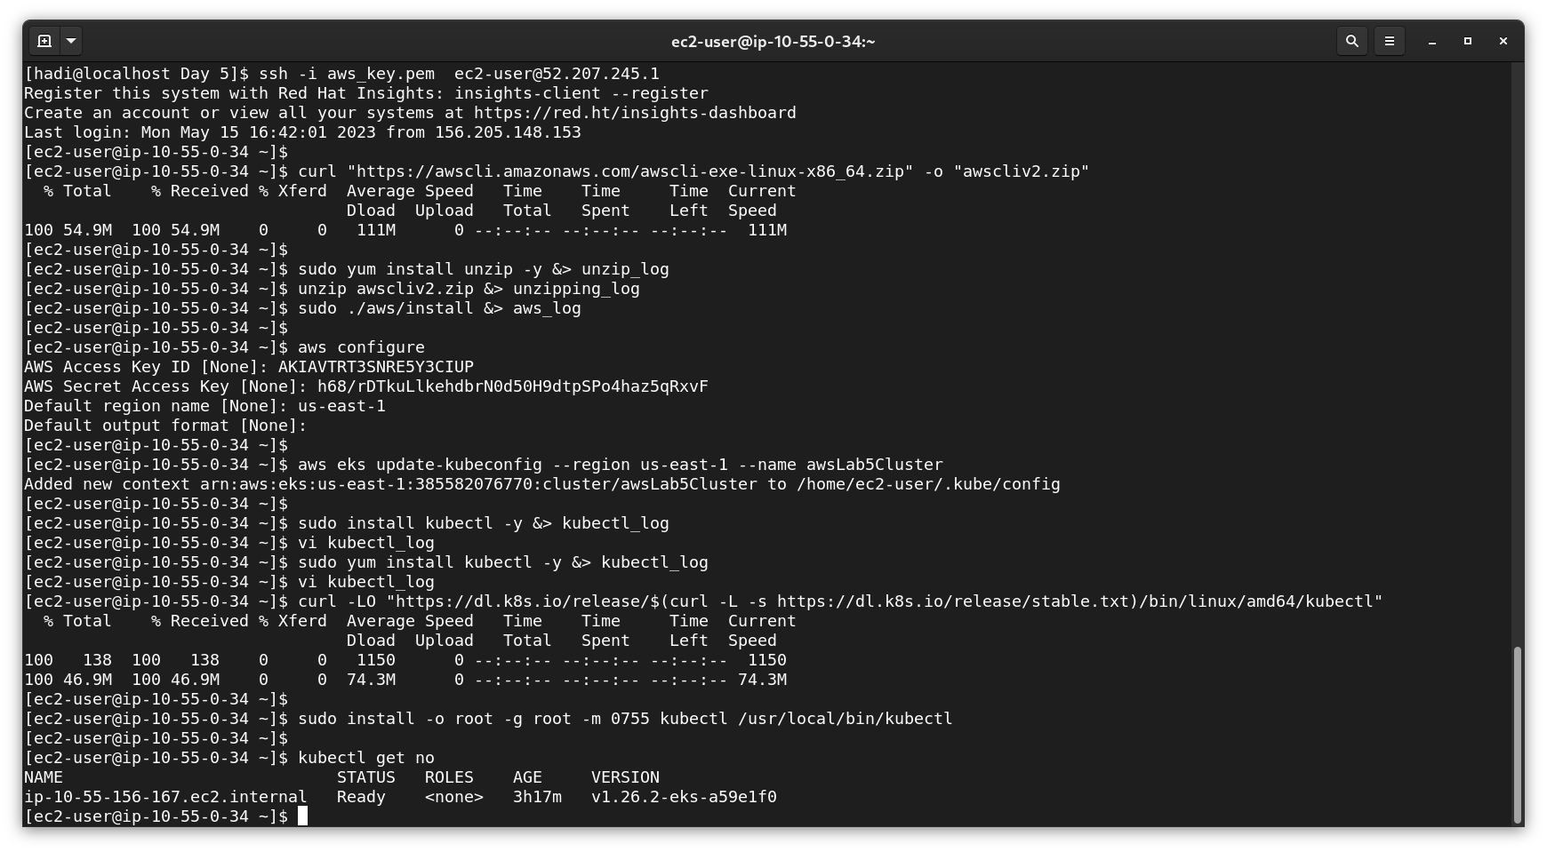

- Cluster is managed by its creator, so if root created it, we cannot directly go use it with an admin account from the cli, to add the admin account (my)
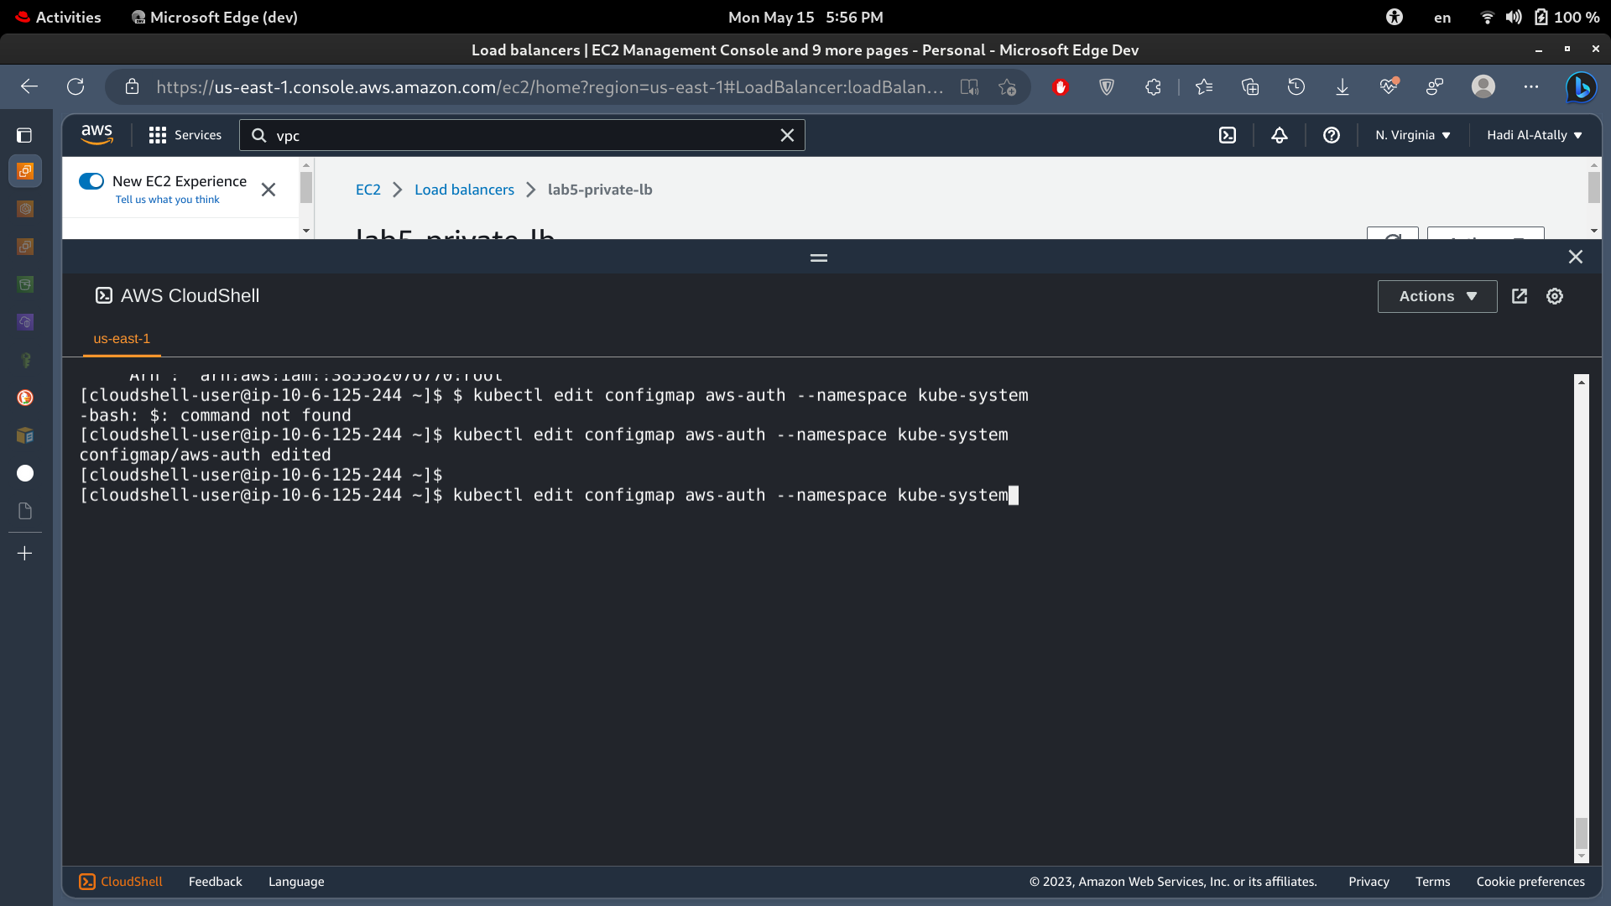
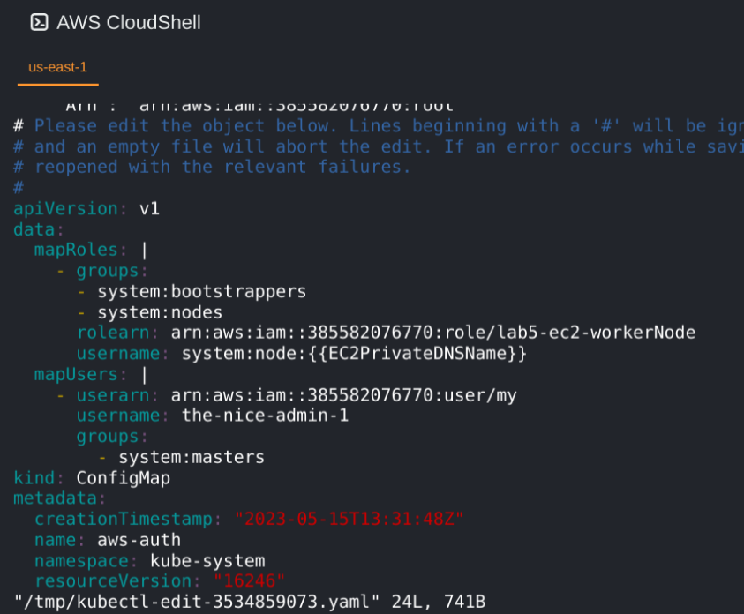
Add the mapUsers section and save the file. Userarn is the arn of the user you need to add as an admin to this cluster.

